实 验 报 告

辽宁科技大学________计算机与软件工程_______学院 2021年 5 月 21 日
课名：Java框架SpringMVC |  | 实验题目：实验五 Spring MVC的Controller
班级：软件18.4 | 姓名:谢靖萱 |  | 学号：120183503202 | 任课教师：张春娜
实验目的：
1、掌握基于注解的控制器
2、掌握Controller接收请求参数的常见方式
实验内容：
IndexController.java
package xjx.controller;

import org.springframework.stereotype.Controller;
import org.springframework.web.bind.annotation.RequestMapping;

@Controller
@RequestMapping("/index")
public class IndexController {
@RequestMapping("/login")
public String login(){
return "login";
}
@RequestMapping("/register")
public String register(){
return "register";
}
}
*****************************************************************
UserController.java
package xjx.controller;

import javax.servlet.http.HttpSession;

import org.apache.commons.logging.Log;
import org.apache.commons.logging.LogFactory;
import org.springframework.stereotype.Controller;
import org.springframework.ui.Model;
import org.springframework.web.bind.annotation.RequestMapping;

import xjx.pojo.UserForm;

@Controller
@RequestMapping("/user")
public class UserController {
private static final Log logger = LogFactory.getLog(UserController.class);

@RequestMapping("/login")
public String login(UserForm user, HttpSession session, Model model) {
if ("sunqiaoqiao".equals(user.getUname()) && "123456".equals(user.getUpass())) {
session.setAttribute("user", user);
System.out.println("登录成功");
return "main";
} else {
System.out.println("登录失败");
model.addAttribute("messageError", "用户名或者密码错误");
return "login";
}
}

@RequestMapping("/register")
public String register(UserForm user, Model model) {
if ("sunqiaoqiao".equals(user.getUname()) && "123456".equals(user.getUpass())) {
System.out.println("注册成功");
return "login";
} else {
System.out.println("注册失败");
model.addAttribute("username", user.getUname());
return "register";
}
}

}
**************************************************************
UserForm.java
package xjx.pojo;

public class UserForm {
private String uname;
public String getUname() {
return uname;
}
public void setUname(String uname) {
this.uname = uname;
}
public String getUpass() {
return upass;
}
public void setUpass(String upass) {
this.upass = upass;
}
public String getReupass() {
return reupass;
}
public void setReupass(String reupass) {
this.reupass = reupass;
}
private String upass;
private String reupass;

}
****************************************************************
springmvc-servlet.xml
<?xml version="1.0" encoding="UTF-8"?>
<beans xmlns="http://www.springframework.org/schema/beans"
xmlns:xsi="http://www.w3.org/2001/XMLSchema-instance"
xmlns:aop="http://www.springframework.org/schema/aop"
xmlns:mvc="http://www.springframework.org/schema/mvc"
xmlns:context="http://www.springframework.org/schema/context"
xsi:schemaLocation="http://www.springframework.org/schema/beans
http://www.springframework.org/schema/beans/spring-beans.xsd
http://www.springframework.org/schema/aop
http://www.springframework.org/schema/aop/spring-aop.xsd
http://www.springframework.org/schema/context
http://www.springframework.org/schema/context/spring-context.xsd
http://www.springframework.org/schema/mvc
http://www.springframework.org/schema/mvc/spring-mvc.xsd">
<context:component-scan base-package="xjx.controller"/>

<mvc:annotation-driven/>

<bean class="org.springframework.web.servlet.view.InternalResourceViewResolver" id="internalResourceViewResolver">
<property name="prefix" value="/WEB-INF/jsp/"></property>
<property name="suffix" value=".jsp"></property>
</bean>

</beans>
*************************************************************
<%@ page language="java" contentType="text/html; charset=UTF-8"
pageEncoding="UTF-8"%>
<!DOCTYPE html PUBLIC "-//W3C//DTD HTML 4.01 Transitional//EN" "http://www.w3.org/TR/html4/loose.dtd">
<html>
<head>
<meta http-equiv="Content-Type" content="text/html; charset=UTF-8">
<title>Insert title here</title>
</head>
<body>
<form action="${ pageContext.request.contextPath }/user/login"
method="post">
<table>
<tr>
<td>姓名：</td>
<td><input type="text" name="uname" class="textSize"></td>
</tr>

<tr>
<td>密码:</td>
<td><input type="password" name="upass" class="textSize"></td>
</tr>
<tr>
<td colspan="2">
<input type="button" value="确认" onclick="gogo()"/>
<input type="button" value="取消" onclick="cancel()"/>
</td>
</tr>
</table>
${messageError }
</form>
</body>
<script type="text/javascript">
function gogo(){
document.forms[0].submit();
}
function cancel(){
document.forms[0].action = "";
}
</script>
</html>
***********************************************************
<%@ page language="java" contentType="text/html; charset=UTF-8"
pageEncoding="UTF-8"%>
<!DOCTYPE html PUBLIC "-//W3C//DTD HTML 4.01 Transitional//EN" "http://www.w3.org/TR/html4/loose.dtd">
<html>
<head>
<meta http-equiv="Content-Type" content="text/html; charset=UTF-8">
<title>Insert title here</title>
</head>
<body>
欢迎你 ${ user.uname }
</body>
</html>
*********************************************************
<%@ page language="java" contentType="text/html; charset=utf-8"
pageEncoding="utf-8"%>
<!DOCTYPE html PUBLIC "-//W3C//DTD HTML 4.01 Transitional//EN" "http://www.w3.org/TR/html4/loose.dtd">
<html>
<head>
<meta http-equiv="Content-Type" content="text/html; charset=utf-8">
<title>Insert title here</title>
</head>
<body>
<form action=" ${pageContext.request.contextPath }/user/register " method="post" name="registForm">
<table border=1 bgcolor="lightblue" align="center">
<tr>
<td>姓名：</td>
<td>
<input class="textSize" type="text" name="uname" value="${ uname }"/>
</td>
</tr>

<tr>
<td>密码：</td>
<td>
<input class="textSize" type="password" maxlength="20" name="upass"/>
</td>
</tr>

<tr>
<td>确认密码：</td>
<td>
<input class="textSize" type="password" maxlength="20" name="reupass"/>
</td>
</tr>
<tr>
<td colspan="2" align="center">
<input type="button" value="注册" onclick="allIsNull()"/></td>
</tr>
</table>
</form>
</body>
<script type="text/javascript">
function allIsNull(){
var name=document.registForm.uname.value;
var pwd=document.registForm.upass.value;
if(name==""){
alert("请输入姓名！");
document.registForm.uname.focus();
return false;
}
if(pwd==""){
alert("请输入密码！");
document.registForm.upass.focus();
return false;
}
document.registForm.submit();
return true;
}
</script>
</html>
***************************************************************
web.xml
<?xml version="1.0" encoding="UTF-8"?>
<web-app xmlns:xsi="http://www.w3.org/2001/XMLSchema-instance" xmlns="http://xmlns.jcp.org/xml/ns/javaee" xsi:schemaLocation="http://xmlns.jcp.org/xml/ns/javaee http://xmlns.jcp.org/xml/ns/javaee/web-app_3_1.xsd" id="WebApp_ID" version="3.1">
<display-name>SpringMvc-Controller1</display-name>
<welcome-file-list>
<welcome-file>index.html</welcome-file>
<welcome-file>index.htm</welcome-file>
<welcome-file>index.jsp</welcome-file>
<welcome-file>default.html</welcome-file>
<welcome-file>default.htm</welcome-file>
<welcome-file>default.jsp</welcome-file>
</welcome-file-list>

<servlet>
<servlet-name>springmvc</servlet-name>
<servlet-class>org.springframework.web.servlet.DispatcherServlet</servlet-class>
<init-param>
<param-name>contextConfigLocation</param-name>
<param-value>classpath:springmvc-servlet.xml</param-value>
</init-param>
<load-on-startup>1</load-on-startup>
</servlet>
<servlet-mapping>
<servlet-name>springmvc</servlet-name>
<url-pattern>/</url-pattern>
</servlet-mapping>
<servlet-mapping>
<servlet-name>default</servlet-name>
<url-pattern>*.gif</url-pattern>
</servlet-mapping>

</web-app>
*******************************************************
<%@ page language="java" contentType="text/html; charset=UTF-8"
pageEncoding="UTF-8"%>
<!DOCTYPE html PUBLIC "-//W3C//DTD HTML 4.01 Transitional//EN" "http://www.w3.org/TR/html4/loose.dtd">
<html>
<head>
<meta http-equiv="Content-Type" content="text/html; charset=UTF-8">
<title>Insert title here</title>
</head>
<body>
如果没注册,请注册<a href="${pageContext.request.contextPath }/index/register">注册</a>！<br>
已经注册的,请登录<a href="${pageContext.request.contextPath }/index/login">登录</a>！
</body>
</html>
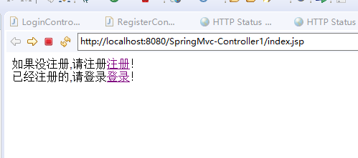

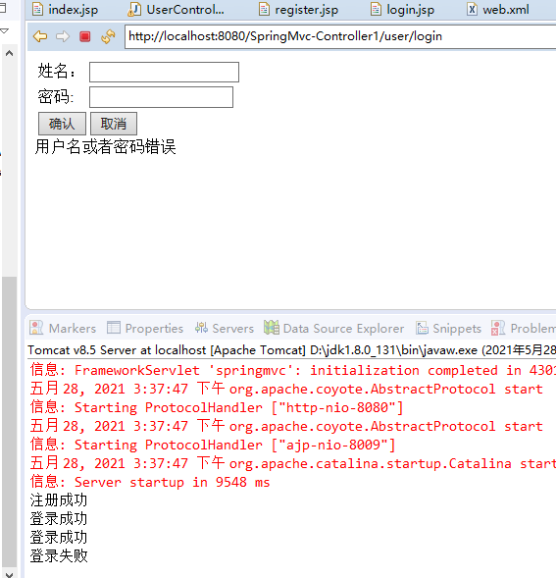

实验心得：
通过本次实验，我学习了Controller接收请求参数的一个方式。通过实体Bean接收请求参数，适用于get和post提交请求方式，很方便使用！
评语：

优：态度认真，遵守纪律，能很好的完成实验内容要求，全面的掌握了专业知识和专业技能，报告结构合理，逻辑很清晰，格式符合规范。
良：态度认真，遵守纪律，能较好完成实验内容要求，较好的掌握了专业知识和专业技能，报告结构合理，逻辑比较清晰，格式符合规范。
中：态度比较认真，遵守纪律，能按时完成实验内容要求，较好的掌握了专业知识和专业技能，报告结构基本合理，逻辑比较清晰，格式基本符合规范。
及格：态度比较认真，遵守纪律，基本能按时完成实验内容要求，基本掌握了专业知识和专业技能，报告结构基本合理，逻辑基本清晰，格式基本符合规范。
不及格：态度不认真，不遵守纪律，不能按时完成实验内容要求，不能掌握专业知识和专业技能，文字不通顺，逻辑不清晰，格式不符合规范。

